**ASP.NET Core Tutorials**

**Layout View:**

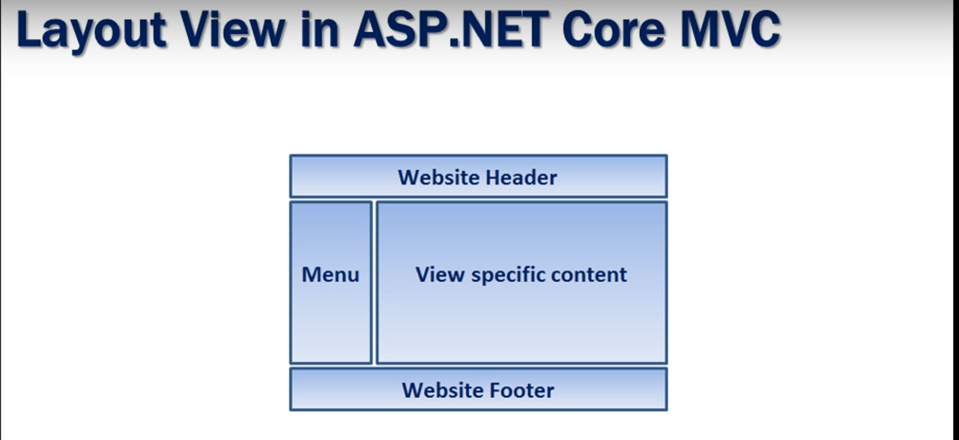

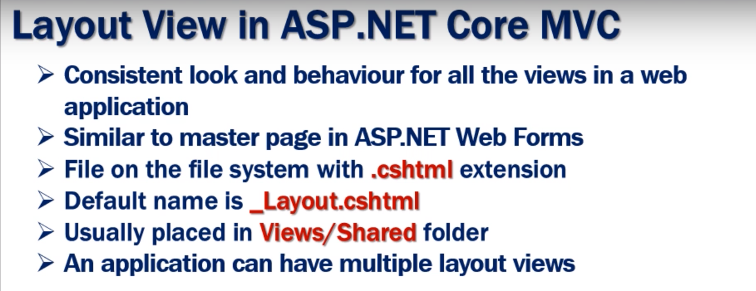

**Sections in Layout Page:**

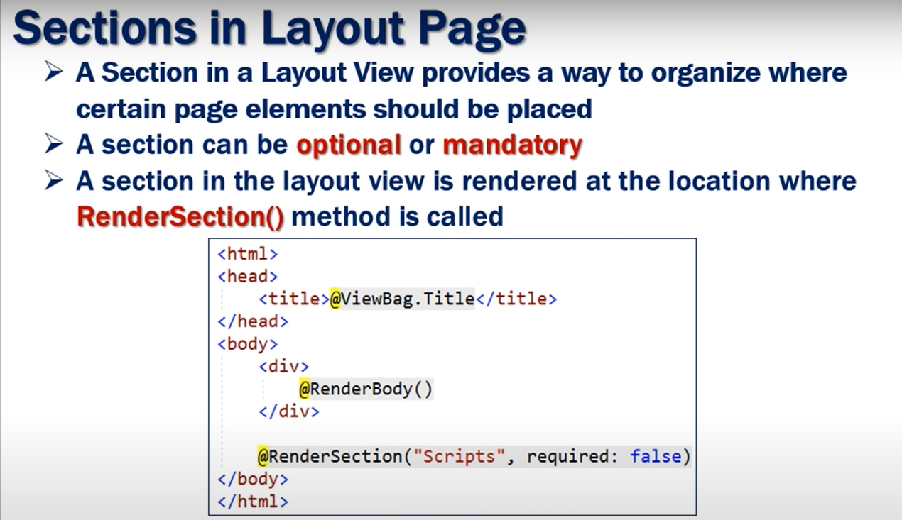

**_ViewStart.cshtml :**

Suppose we have thousands of View pages and a one _Layout for all of them. Now we want to change the _Layout for all of them. Then we have to add the path of new _Layout to all them which is a tough task. Here comes ViewStart in which we can define the _Layout which will be used for all the pages. If we want a different _Layout for some of the pages then we can define individual _Layouts which will override the general one. We can have multiple _ViewStart pages in Main or Sub Folders which will be Hierarchical which means child/Subfolder pages will override the Parent or Main folder pages.

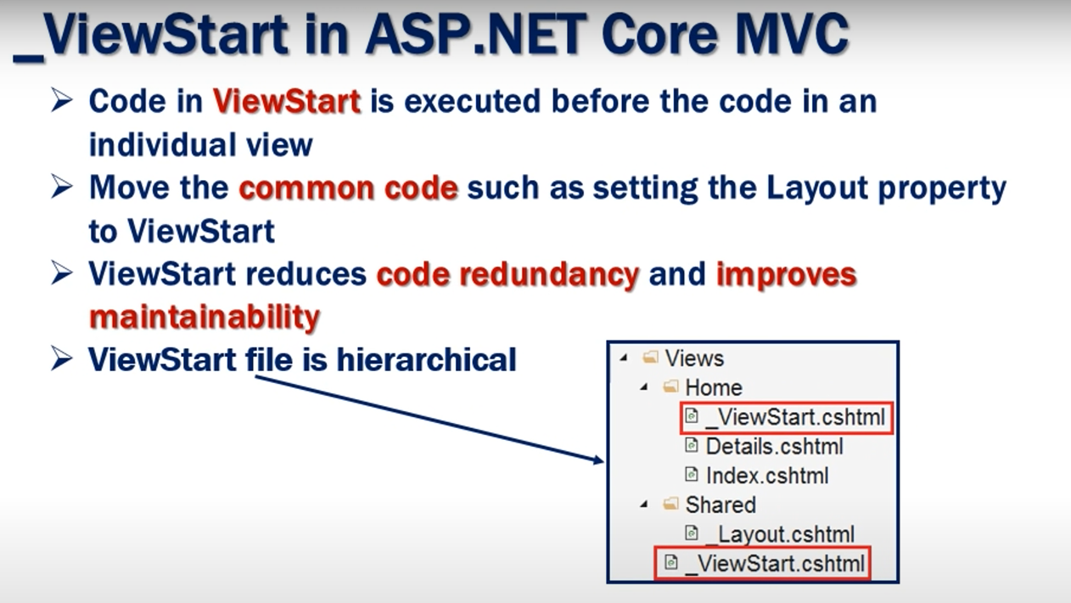

**_ViewImports.cshtml :**

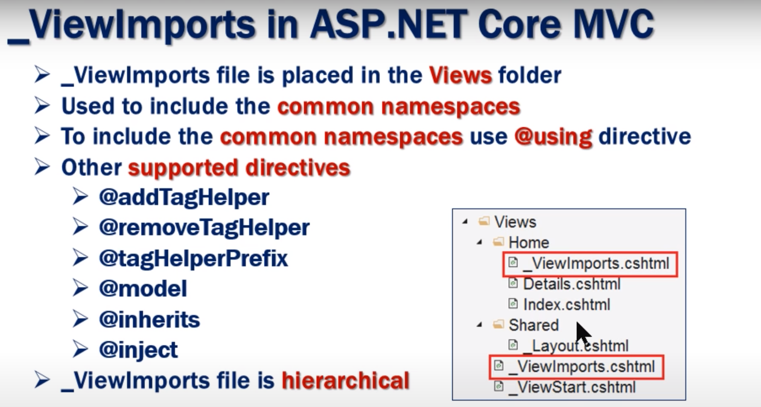

**Routing :**

Two types of Routing Techniques:

1. Conventional Routing
2. Attribute Routing
3. **Conventional Routing:**

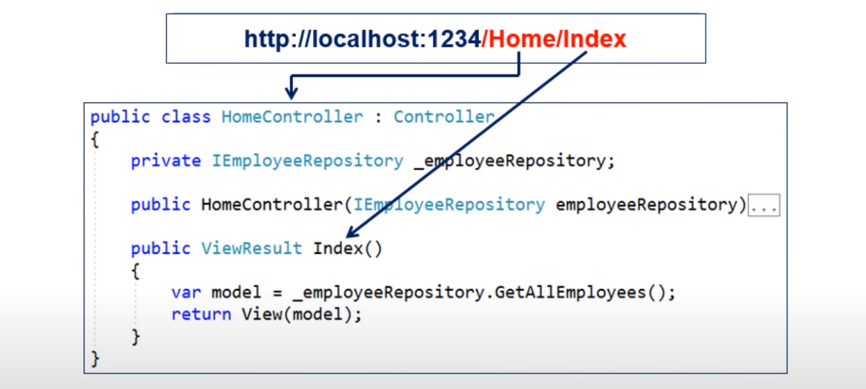

It is called mapping of the Http request.

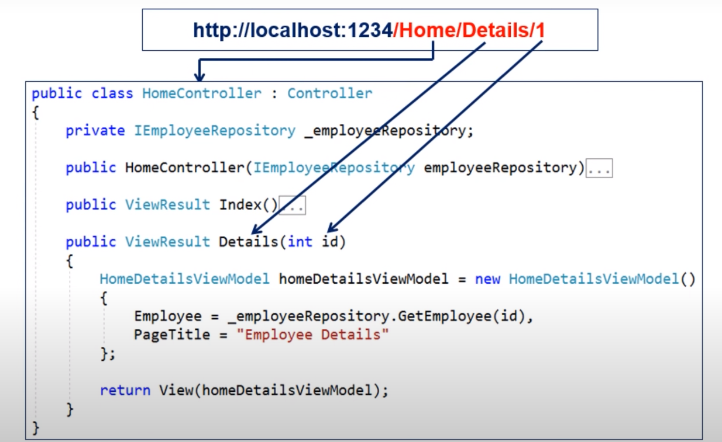

Using Default Mapping:

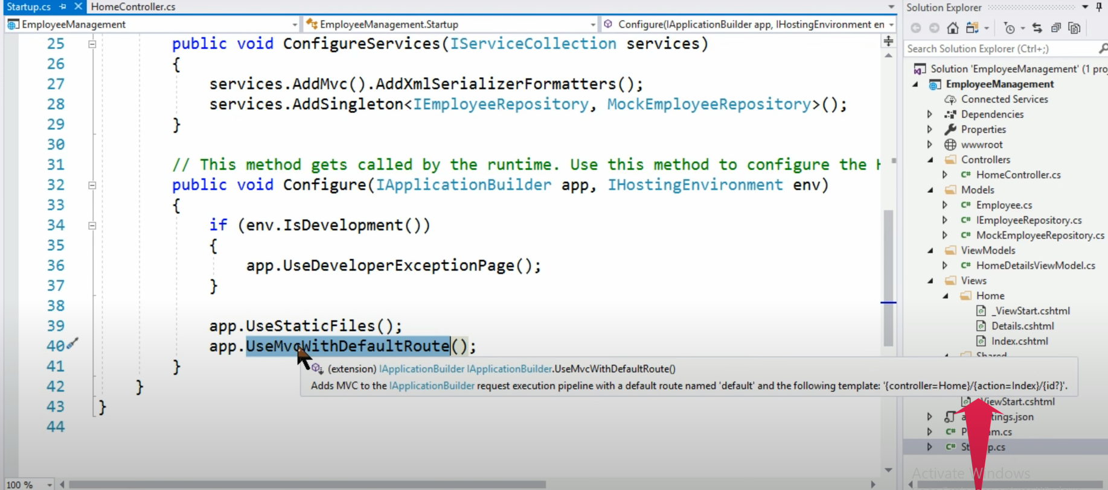

Using Custom Mapping:

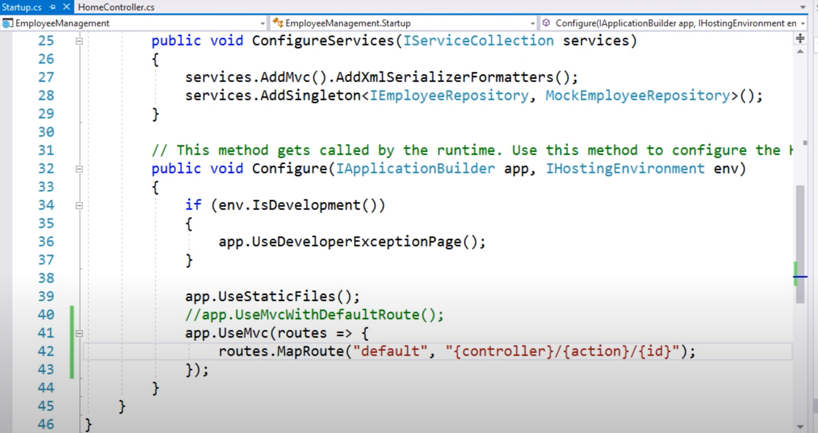

If we are using our custom Mapping of Route and want to make id section optional then just add question mark at the end of id section as shown below. If we want our route to go for default path to Home and default action to Index then make controller equal to Home and Action equal to Index in Custom Route Mapping.

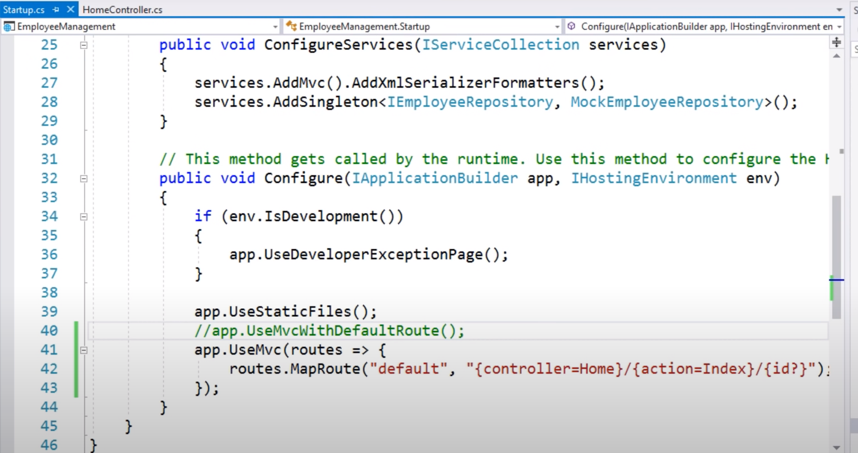

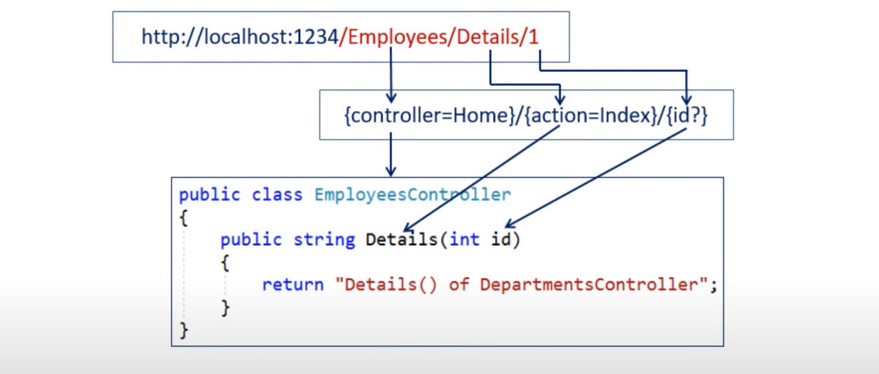

1. **Attribute Routing:**

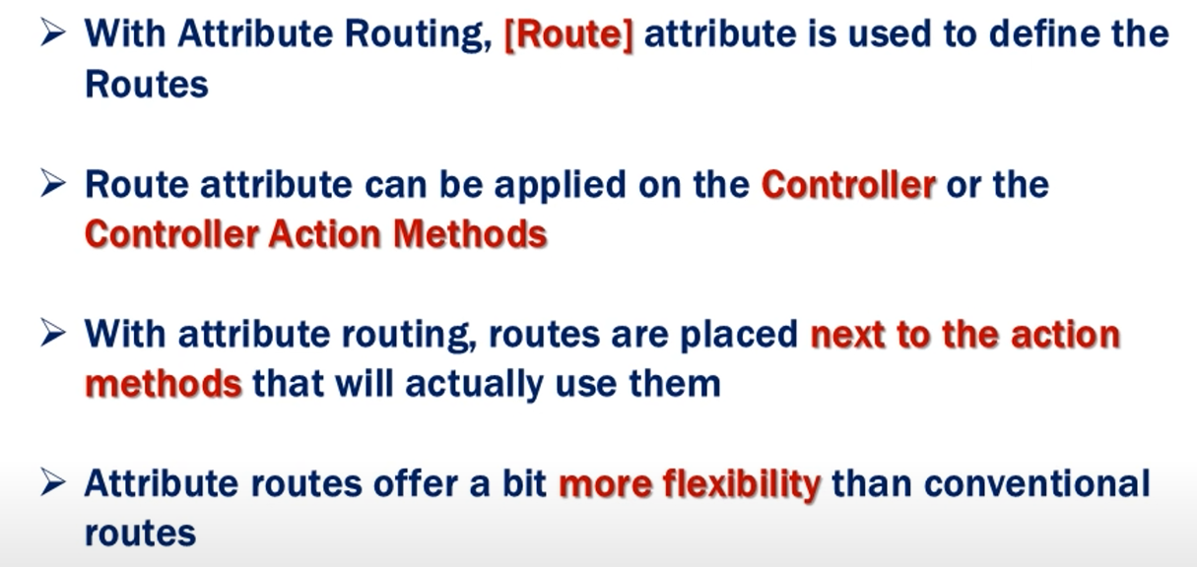

Attribute routes are Hierarchical which means the routes on Controller are combined with the routes on Actions.

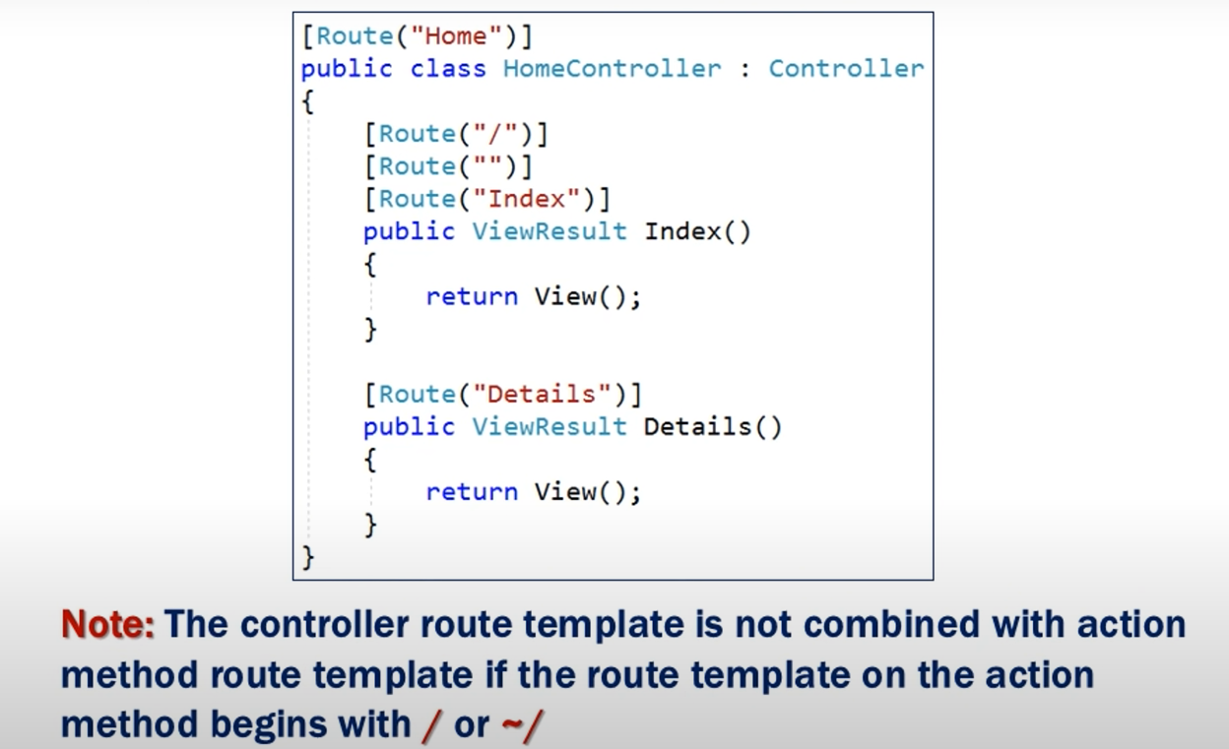

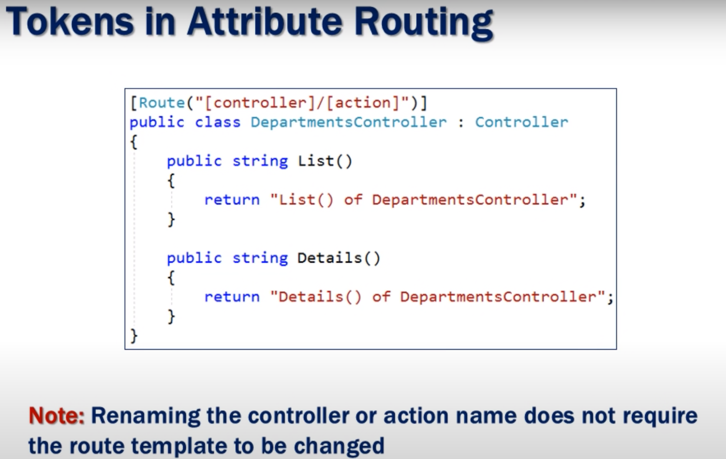

**Image Tag Helper (Bootstrap):**

